BCS Student Uniform Basics
Recommended Minimum Set of Student Uniforms from
Dennis Uniform (Grades K4-5)
(Please note: Uniform pieces cannot be purchased from other retail stores.)
Boys:
- 3 shirts – one white oxford or polo for Chapel Day, two polo shirts in either black, hunter green, or navy blue while supplies last
- 2-3 shorts
- 1 pair pants (with belt for all pants with belt loops) required for Chapel Day on designated months
- 1 BCS hoodie or jacket to be worn during school hours when it is cold
- 1 field trip t-shirt
Girls:
- 1 plaid jumper or plaid skirt (required for Chapel Day)
- 1 white blouse, oxford, or polo (required for Chapel Day)
- 2 polo shirts – either black, hunter green, or navy blue while supplies last
- 2 or 3 bottoms or dresses (skirt, jersey polo dress, shorts, or pants)
- 1 BCS hoodie or jacket to be worn during school hours when it is cold
- 1 field trip t-shirt

Recommended Minimum Set of Student Uniforms from
Dennis Uniform (Grades 6-12)
(Please note: Uniform pieces cannot be purchased from other retail stores.)
Boys:
- 3 polo shirts –black, hunter green, or navy blue while supplies last
- 2-3 shorts
- 1 pair pants (required for All-Community Chapel Day)
- 1 white oxford shirt (required for All-Community Chapel Day)
- 1 BCS hoodie or jacket to be worn during school hours when it is cold
- 2 sets of p.e. uniforms – t-shirt and shorts
- Any kind of belt required to be worn on All-Community Chapel Day
Girls:
- 1 plaid skirt for daily use and All-Community Chapel Day
- 1 khaki bottom (skirt, shorts, or pants)
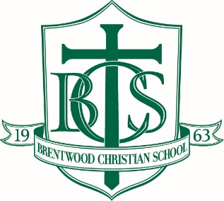
- 1 white blouse or oxford (required for All-Community Chapel Day)
- 3 polo shirts –black, hunter green, or navy blue while supplies last
- 1 BCS hoodie or jacket to be worn during school hours when it is cold
- 2 sets of p.e. uniforms – t-shirt and shorts

- Uniform pieces must be purchased from either Dennis Uniform or the campus uniform resale (typically held in July or August) as these pieces have our BCS logo and meet the uniform requirements. Uniform pieces cannot be purchased from other retail stores.

- All students may wear any BCS t-shirt with their uniform bottoms on Fridays.

- Elementary students (K4-5th grade) are required to wear the chapel day uniform on all chapel days, including All-Community Chapel Days. Secondary students (6th-12th grade) may wear any of their uniform pieces on their regular chapel days and are required to wear the chapel uniform on All-Community Chapel Days.

- Please refer to the Elementary, Middle School, and High School Parent-Student Handbooks for the guidelines on the proper attire for chapel and All Community Chapel days.

